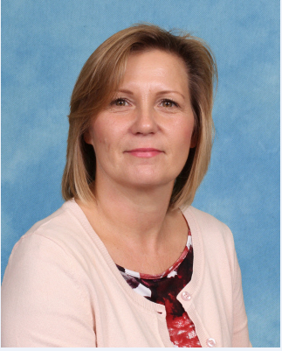
Hello, my name is Jacqui King. I am the Family Liaison Officer for parents, carers and families of Purbrook Infant School.

I have worked at Purbrook Infant School for 22 years in various roles across the school. I started working here when my children started at this school and have seen families’ needs increase, be it behaviour strategies, mental health, information and guidance or just someone to chat to.

Here are some of the ways I can help:

- Support for you with your child’s learning and school attendance working with teachers and senior leadership
- Provide support and signpost services that can help you and your child with bereavement, abuse welfare and adult learning opportunities etc
- Help with form filling or on-line applications
- Provide a listening ear to families
- Trusted adult in the school

I am around every weekday morning and you can contact me through the school office or catch me in the playground at drop off time.

(All information is strictly confidential subject to child protection guidelines)

