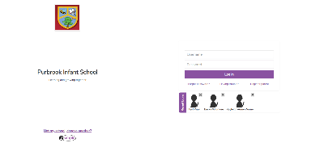
Step 1:
Visit the school login page (https://purplemash.com/purbrok-infant)
Step 2:
Click Register Parent.

Step 3:
Enter your details including the Parent Code on your child’s login slip.

Then continue to follow the instructions on the next page to create a Portal Account, which will help you to keep up to date with your child’s learning online.

Step 4:
Login with your child using their username and password.
This is on the login card; the username is your child’s full name (with a space in between) and the password is ram

Step 5:

You can now access the “To Do” section to find any new assignments set by your child’s class teacher.

OR
Access the Blog section by clicking Sharing, Shared Blogs and selecting your Year Group Blog page.

Step 6:
You can add your own blog posts or comment on posts from other people, but remember that they are visible to all members of your child’s Year Group. This would be a good place to find or share other learning links such as websites and resources, from both other parents and school staff.

