**BIG CAT DIARY**

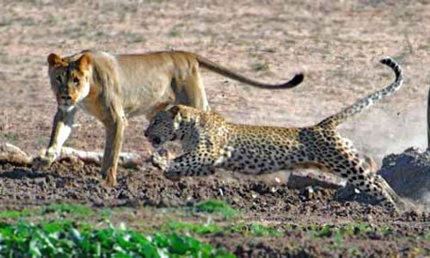

Here comes a lioness stalking through the grass. Honey the cheetah has seen her and knows that there is danger coming. Her body posture changes and she darts through the field as quick as the wind towards her cubs. The cubs are staying where they are, being quiet in the grass but the alert lioness has seen them. As the lioness slowly approaches them, they scatter off running in different directions. Honey starts to growl to warn her cubs about the dangerous cat stalking towards them. Suddenly, the brave cheetah Honey runs at the lioness and scares her away from her cubs. This is quite unusual for a lion to be scared of a cheetah!