Emu Eggs
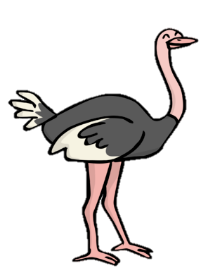
Three birds laid some eggs. Each bird laid an odd number of eggs. Altogether they laid 11 eggs.
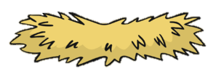
How many eggs did each bird lay?
Find different ways to do it.

Emu Eggs
Three birds laid some eggs. Each bird laid an odd number of eggs. Altogether they laid 19 eggs.
How many eggs did each bird lay?
Find different ways to do it.

