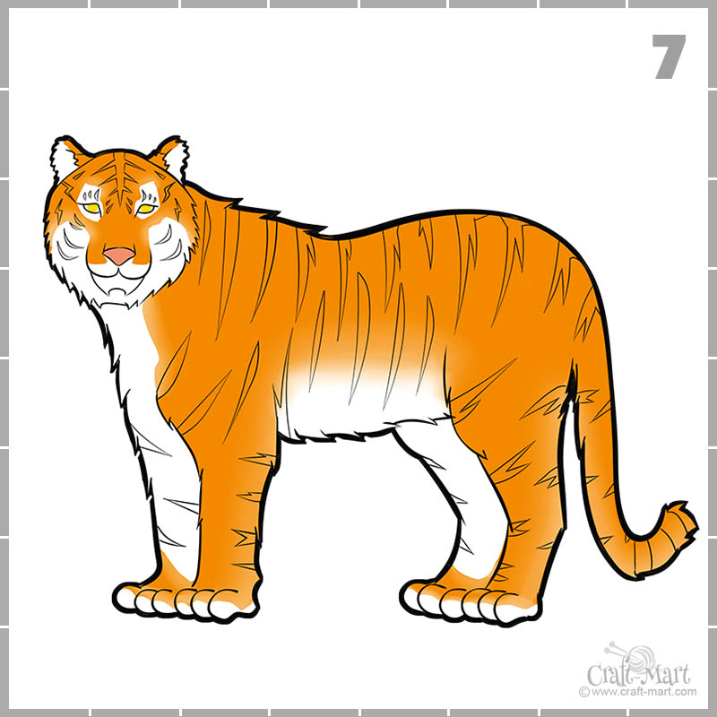

**What can be done?**

The main thing that can be done to help the wild tigers is to help rebuild their natural habitat so they can breed and can have their own territories. Tigers are solitary animals which means they mostly like to live alone and they need more than 7 miles of territory to roam and be happy. There should be more done to track tiger numbers and more laws put in place to protect tigers from humans. I think that Tigers should be given land that is free from human contact and that people should be taught how to keep them safe.

**Problems for the tiger**

1. Habitat is being destroyed
2. Hunted by humans
3. Less food for them to hunt
4. Not enough tracking to protect them.

Tigers are a beautiful and powerful animal that are mostly found in Asia. However, almost 95% of their habitat has been destroyed and there is now less than 4,000 tigers left in the wild! This is shocking but the good news is that there are lots of conservation organisations who want to help!

**SAVE THE TIGER**