Year 2 home learning – Summer A Week 7
Dear Parents and Carers, here is an overview of tasks we’d like the children to complete at home this week. We hope you are all keeping safe and well and are making sure you are having a balance of learning, relaxing and following things that you are interested in. Remember you can send any of your children’s work via email or post it on the Purple Mash blog.
Reading: Daily reading- please keep up with your daily reading this week and feel free to share any amazing books you’ve read on our Purple Mash blog.  Reading online – This week it might be a nice change to check out the Literacy Shed website which has so many fantastic reading and comprehension videos and tasks.  The one we have chosen for you this week is the Night Zookeeper. See if you can answer the questions before you watch the story and then have a go at the ones for after you’ve seen it. You can even have a go at creating your own character.  https://www.literacyshed.com/nightzoo.html# | Writing: Big Cats  Task 1: This week we are going on a safari in search for big cats. We are going to write a short commentary to describe what we can see the big cats doing (think David Attenborough style). To help inspire you, have a look at this link and make a note about the type of things the commentator says.  https://www.youtube.com/watch?v=N_oStkrmsxU&safe=true  This is a video about a brave cheetah called Honey chasing off a lioness. There are many other videos about different cats on YouTube but please can adults watch first as some include detailed hunts that may cause alarm. Please see our WAGOLL to support you with this on our website.  Task 2: Endangered animal poster  Many of the big cats we have been looking at the past few weeks are endangered and some have alarmingly low numbers. This week we would like you to choose a cat of your choice (tiger, leopard, cheetah, lion, hyena, cougar etc) and create an information poster about that animal, highlighting problems that animal is facing, a few facts and some possible ways to help. Please see the WAGOLL to help you and there is a template to use if you wish.  Don’t forget to check your writing for capital letters, full stops and check with someone else at home that your writing makes sense. | Maths: Data  This week we are looking at data, in particular showing data in a tally chart and bar chart. Attached on the website are two sheets that you can choose from (first one is orange and the second one is green which is more complex). You will need to correctly tally the numbers and then draw the bars on to the graph to show the number. You only need to complete one of the sheets.  Extension: Can you answer some questions about the data?  Maths task 2: Emu Eggs problem solving.  Please see this problem attached to the website. You might want to use jottings, drawings or counters to help you work out the problems but remember- if you stick at it and try out different possibilities you will find some answers.
Art: Art Project – Year 2  There have been many artists who have used nature as inspiration for their art and we are asking you to use this inspiration to make your own work of art over the next three weeks. The rules are simple, use nature as a stimulus to create art work that can be photographed/taken back to school to share when the time is right. Your art must be no larger than A4 size but can include any art form (drawing, painting, collage, sculpture, print etc.). There will be winner at the end of this project who will receive a prize!  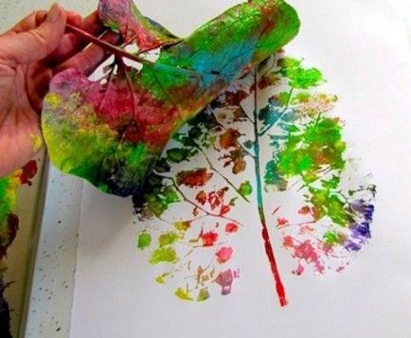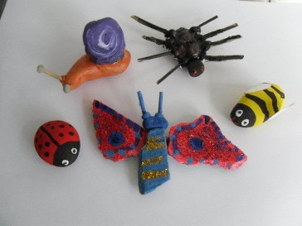 | Spellings: Homophones  This week’s focus is going to be around using homophones (two words that sound the same but are spelt differently and have different meanings).  Please put these homophones in to a sentence (they can be as silly as you like as long as you make the meaning of the homophone clear). Then choose 4 of them as spellings to try to remember. You might want to cut the words up and put them back together, try rainbow writing or even chalk them outside- be as creative as you like. | Topic: Geography  For geography this week we would like you to create your own safari at home. You can do this one of two ways, you may want to draw a map with a key to show what can be found on your safari (similar to the Disney one we did at school) or you can draw out a safari route and give compass directions for a visitor to use.  Extension: You may want to go on to Google Maps or Google Earth and check out some different safaris.
Science: Living, not living and never lived.  This week we are focussing on things that are alive, not living and never lived. You will need to refresh your memory of MRS GREN to help you to remember what something needs to do to be classed as ‘living’.  https://www.youtube.com/watch?v=RpZUCo_rKLc&safe=true  What I would like you to do is draw a picture for something that is living, not living and never lived and label the pictures to explain.  E.g. A bubble has never lived. Even though it does move through the air, it is made from soap and water and can’t breathe or reproduce. | PE: Gymnastics  This week we would like you to create a gymnastics routine that can showcase all the skills you have been practising over the past few weeks. It must include.  - Two different ways of travelling (side step, hop, spider crawl etc)  - Two different rolls (teddy-bear, log, tuck but no forward or backward rolls please)  - Two different balances (dish, side-support etc) | PHSE: Emotions and self-belief  This week I would like you to have a look at this lesson on BBC bitesize which is focussed around managing your feelings and self-belief. There are a few videos to watch and there are two activities that you can choose from but what we would like you to do most of all is have a talk with your adults about what can make you feel like you are losing control of your emotions and what you can do to bring your feelings back down from red to green.  https://www.bbc.co.uk/bitesize/articles/zmmgrj6

