The sections in green are extension tasks. If your child is able to apply the skills taught independently and confidently they should attempt these questions. The final challenge question should generate several different possible answers.

10 - 10 = __  9 - 9 = __  8 - 8 = __  7 - 7 = __  6 - 6 = __  5 - 5 = __ |  | 4 - 4 = __  3 - 3 = __  2 - 2 = __  1 - 1= __  0 - 0 = __
53 – 53 = __
99 – 99 = __
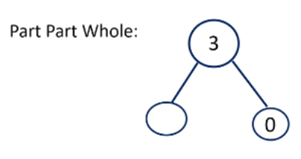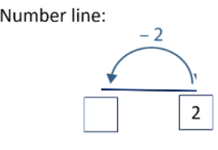
4 – 4 = __ |  | __ - 1 = 0
__ - 9 = 0 |  | 5 - __ = 0

Challenge:
How many ways can you complete
- = 0

