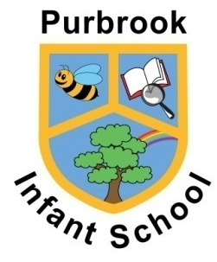

Purbrook Infant School
Curriculum Intent: DARE to Learn

At Purbrook Infant School, our Knowledge Led Curriculum is designed to develop the following key qualities in our children:

DILIGENT – I always work hard
ASPIRATIONAL – I want to be the best that I can be
RESILIENT – I stay positive when things get tricky
ENTHUSIASTIC – I am interested in all that I learn and do

Our curriculum enables our children to demonstrate these qualities in lessons. Much more than that, we believe that these values form a key part of our wider-school ethos; we develop children who are able to meet the challenges of all aspects of infant school life and who are equipped with the knowledge, skills and personal qualities they will need for the next steps of their academic journey.

At Purbrook Infant School we follow a Knowledge Led Curriculum, underpinned by Metacognition and Self – Regulated Learning strategies, developed carefully and sometimes subtly through High Quality First Teaching.

What is a Knowledge Led Curriculum?

Skills and understanding are seen as forms of knowledge and it is understood that there are no real generic skills that can be taught outside of specific knowledge domains. A knowledge rich approach is one in which our curriculum leaders are clear on the invaluable knowledge they want their student to know, essentially it is designed to help our students remember what has been taught.
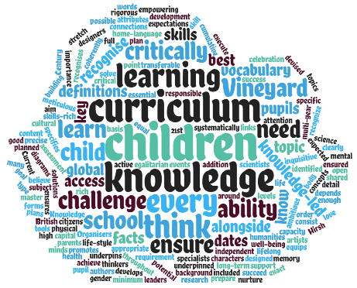

Acquiring knowledge is seen as an end to itself; there is a belief that we are all empowered through knowing things and that this cannot be left to chance.

Purbrook Infants believe that the creative, 'rounded and grounded’ children we all want to develop – with a host of strong character traits – will emerge through being immersed in a knowledge-led curriculum.

Knowledge Is Taught To Be Remembered,
Not Merely Encountered.

Our units of work are supported by ‘To Be able to’ objectives that detail the knowledge to be learned. These are carefully supported by a set of Metacognition and Self Regulations prompts to support how we approach our learning

We do not merely want to ‘do the fire of London’; we want children to gain some specified knowledge of the fire event as well as a broad overview. We want children to know specific facts about plants and about the environment, dinosaurs, the south pole and climate change.

We want children to have more than a general sense of a topic through vaguely remembered knowledge encounters; in addition to a range of memorable, enriching experiences from which important inferred knowledge is gained, we want them to gather a body of specific facts and procedural knowledge – not ad hoc but clearly planned for.

Being Knowledge Rich…

Our Curriculum Ethos:

- Our curriculum is designed to be remembered in detail - to be stored in our students’ long-term memories so that they can later build on it, forming ever wider and deeper understanding.
- Our approach runs through every stage in school; units of work are not defined by headings but by details.
- Our Knowledge Led Curriculum (KLC) is sequenced and mapped deliberately and coherently.
- Our Knowledge Led Curriculum is packed with experiences and is driven by our values and intent about what matters; it has depth and moral purpose.
- Our Knowledge Led Curriculum (KLC) is underpinned by Metacognition and Self-regulation skills, taught and developed to support children’s understanding of how they learn, remember and retrieve information.
- Our learning environments will be set up to ensure learning is embedded and revisited, such that their knowledge would be built on, not left behind.

Reading, Language and Vocabulary at the Core of our Curriculum…

Books enable children to discover new worlds, meet new people and learn about the past, but they also have the power to transform lives.

By sparking growing imaginations, stimulating critical thinking and helping to develop empathy, reading and talking gives children the very skills they need to succeed at school, at work and in life.

Helping children discover a love of reading and new words and language is crucial; a golden thread that runs through out Knowledge Led Curriculum, opening worlds and new facts for children every step of the way!

