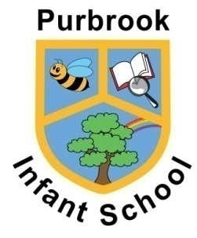 | PURBROOK INFANT SCHOOL  ALDERMOOR ROAD EAST, PURBROOK PO7 5NQ  Telephone: 023 9261 0761  Email: adminoffice@purbrook-inf.hants.sch.uk  Headteacher: Lisa A de Carteret  Assistant Headteacher: Paul Stray  School Business Manager: Hazel K Dean

16 September 2022

Dear Parents/Carers

We have loved welcoming your children into Year R and have spent the last few days getting to know their personalities, likes and dislikes, and making them feel welcome and happy in school.

Now that they have begun to feel slightly more settled, we will begin to complete the government Reception Baseline Assessment with each child. This is a statutory requirement which was introduced this year.

The assessment is a ten-minute maths activity and a ten-minute literacy, communication and language activity completed 1:1 with your child’s teacher. The children are unaware that they are being assessed and the activity is sold as a ‘fun job’ where they get to spend some time with a familiar adult and earn stickers. It is not a pass/fail assessment and there is no final score or judgement passed; the purpose of the assessment is to provide the government with a starting point for school entry which will show how much progress your child makes when they reach Year 6.

If you have any questions about the Baseline Assessment, ask your child’s class teacher or visit https://assets.publishing.service.gov.uk/government/uploads/system/uploads/attachment_data/file/1074327/2022_Information_for_parents_reception_baseline_assessment.pdf

Yours sincerely

Miss R Wigmore
Early Years Phase Leader

