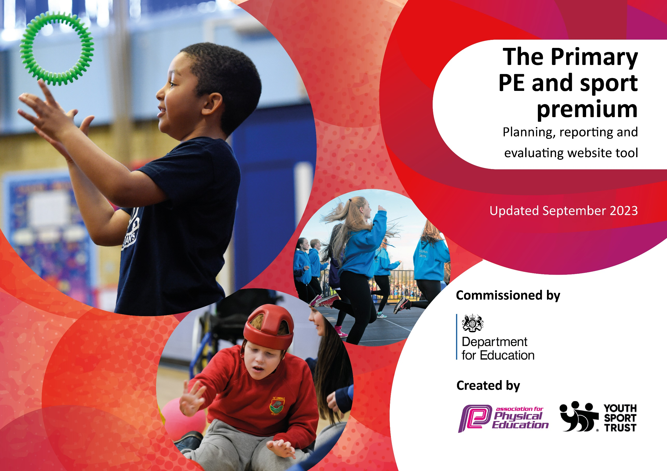

It is important that your grant is used effectively and based on school needs. The Education Inspection Framework makes clear there will be a focus on ‘whether leaders and those responsible for governors all understand their respective roles and perform these in a way that enhances the effectiveness of the school’.

Under the Quality of Education Ofsted inspectors consider:
Intent - Curriculum design, coverage, and appropriateness
Implementation - Curriculum delivery, teaching (pedagogy) and assessment
Impact - Attainment and progress

To assist schools with common transferable language this template has been developed to utilise the same three headings which should make your plans easily transferable between working documents.
Schools must use the funding to make additional and sustainable improvements to the quality of Physical Education, School Sport, and Physical Activity (PESSPA) they offer. This means that you should use the Primary PE and sport premium to:

• Develop or add to the PESSPA activities that your school already offer
• Build capacity and capability within the school to ensure that improvements made now will benefit pupils joining the school in future years
• The Primary PE and sport premium should not be used to fund capital spend projects; the school’s budget should fund these.

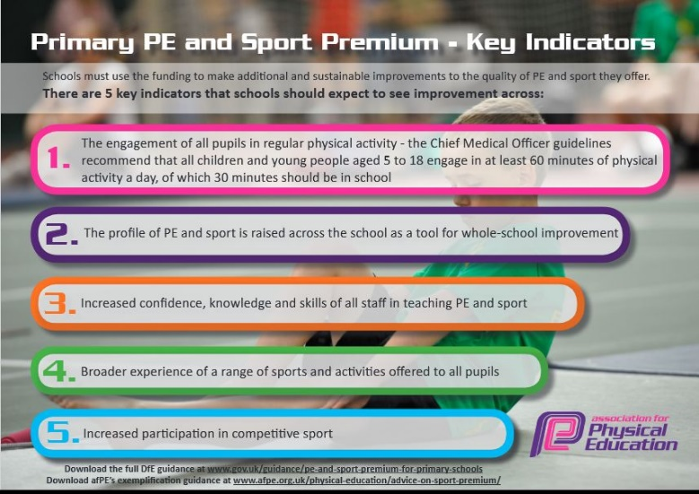
Please visit gov.uk for the revised DfE guidance including the 5 key indicators across which schools should demonstrate an improvement.

Schools are required to publish details of how they spend this funding, including any under-spend as well as on the impact it has on pupils’ PE and sport participation and attainment. The funding should be spent by 31st July but the DfE has stated that there will be no claw back of any unspent money so this can be carried forward into 2023/24. We recommend regularly updating the table and publishing it on your website throughout the year. This evidences your ongoing self-evaluation of how you are using the funding to secure maximum, sustainable impact.

Review of last year’s spend and key achievements (2022/2023)

We recommend you start by reflecting on the impact of current provision and reviewing your previous spend.

Key indicators | Activity/Action |  | Impact | Comments
Key indicator 1: The engagement of all pupils in regular physical activity  Total Spend: £37016.00 | ABC program (intervention) | £100.00 | ABC program has been aimed at the pupils with varied learning needs. The design of it is it to aid fine and gross motor skill development, which we have seen an improvement. Therefore, the intervention has been successful for a very little expenditure. | - When the CPD for SEND is completed (Spring 2024), our plan is to introduce further inclusion-friendly interventions
 | Climbing area for Reception | £35835.00 | This exceeds of schools annual PE budget. However, its impact has been huge in supporting younger pupils in understanding that developing their motor skills can impact their overall learning abilities. This is a great investment as it will last for years with appropriate maintenance. | - Forecast maintenance money within next year’s PE budget.
 | PE lunchtime cover | £1081.00 | The employment of a lunchtime PE leader meant that pupils had an opportunity to participate in organized physical play. This showed improvement in behavior, participation and enthusiasm to be active during break and lunchtime. | - Forecast employing or retraining staff to continue with this into next year’s PE budget.
Key indicator 2: The profile of PE and sport is raised across the school as a whole school improvement  Total Spend: £1703.10 | Equipment purchase | £1438.00 | New equipment purchase has been a much needed spend. Having access to new playtime equipment allowed pupils to participate more actively during lunch and break. The equipment purchase for PE lessons has allowed us to teach varied sports easily and more effectively than before (tennis, basketball, multi skills) | - Audit existing equipment and write inventory for future requirements.
 | Equipment service/replace | £265.10 | This is an annual fee of servicing and replacing PE equipment. | - This is a continued service through Hampshire
 | PE WOW board | £0 | Introducing this has given children opportunities to showcase their achievements and successes as part of the school’s community. Children and families have sent in images of children being engaged in competitions, extra-curricular and community clubs following the introduction of the PE board in the hall. | - As a PE leader, I will engage with parents to find out children’s sporting habits.
 | Medals for PE lessons | Part of PPA package | Internal competitions have raised the profile of competitive sport within school. It has benefited both motivation to try their best as well as enthusiasm of all pupils when participating in PE lessons. | - Continue with the medal system and incorporate this with the school DARE values.
Key indicator 3: Increased confidence, knowledge and skills of all staff in teaching PE and sport  Total Spend: £8255 | Quality Planning Scheme of work support alongside specialist teaching support | £7850 | Using quality sports specialists alongside teachers ensures children receive a high level of PE teaching during their lessons. The Sports4Primary staff ensure that all children have the opportunities to take part in PE lessons regardless of ability or barriers. Furthermore, they have been a vital part of planning and assessment of PE in our school. They have also been essential for the success of our Sports day. | - In Autumn 2023, team teach type CPD will be provided to KS1 teachers in topics they have identified as most necessary.
 | CPD in gymnastics for Y2 | £250 | School had an amazing opportunity to enhance the teaching of gymnastics. Qualified gymnastics coach from Raw Gymnastics ran 2 workshops with the children and teachers were able to have a study session with the specialist. Children were overjoyed to use varied equipment that was provided and learn new skills. Teachers noted being more confident in teaching gymnastics after the training session. | - More CPD sessions needed. In spring 2024 further inclusion in PE training will be delivered.
 | Hampshire PE coordinator meetings + virtual PE conference | £155 | Having access to the PE coordinators meetings/recordings as well as participating in varied CPD opportunities has been paramount in leading the subject. Knowing about developments in school sport as well as having access to specialist training (nutrition, mental health, specialist sports – tennis) is beneficial for engaging and facilitating pupils’ learning and delivering of physical activities to the rest of the school. | - New bookings will be made for both leadership meetings as well as the conference in April 2024.
Key indicator 4: Broader experience of a range of sports and activities offered to all pupils  Total Spend: £0 | After school club (Legacy club)  After school club (musical dance) | £0 | Offering varied activities for after school club or facilitating sports clubs has made new sports accessible for everyone. The legacy club allows anyone to participate (40% SEND/Disadvantaged/PPF) and take part despite potential social, academic or physical barriers to sport. | - More sports afterschool clubs needed (starting basketball club in Autumn 2023 and girls football club in Spring 2024)
Key indicator 5: Increased participation in competitive sport  Total Spend: £400 | Participation in Havant School Sports games (minibus) | £250 | Renting the minibus has been vital for our school to get to the Havant School games competitions. Some of the competitions have been as far as Portsmouth (gymnastics and quadkids). | - Continue to provide opportunities for competitions.  - Signpost parents to specialist clubs for children showing particular skill.  - Promote successes within the community.
 | Participation in Havant School Sports games (Fee) | £150 | Children are taught about developing their physical skills, thinking skills, social skills and personal skills through each of the sporting opportunities. The success is clear when conferencing pupils about their experiences. They have found it beneficial to have opportunities to try new and different physical activities.

Key priorities and Planning 2023 - 2024

Key indicator to meet | Action – what are you planning to do | Who does this action impact? | Impacts and how sustainability will be achieved? | Cost linked to the action
Key indicator 1: The engagement of all pupils in regular physical activity | Introduce more afterschool clubs that are PE related (linking to other areas of curriculum as well). | Children – more opportunities to participate in after school clubs. | These will be offered free for some of the students and reduced rate (sports4primary).
Key indicator 1: The engagement of all pupils in regular physical activity | Re-introduce Active Breaks during break and lunch times to re-engage pupils in physical activity | Children – they will take part of active, physically challenging games during break. | Having someone to facilitate active breaks will ensure the behavior improves during break and lunch. Having safe equipment out will keep children busy which in return will improve motivation, skill and enthusiasm towards PE and other learning.
Key indicator 1: The engagement of all pupils in regular physical activity | Continue providing physical and social interventions | Children – taking part to improve certain aspects of physical development  Staff – providing the interventions to high standards | Continuing boot camps and special physical activity time for students with special educational needs (first introduced Sept 2022) will give children a chance to enjoy physical education and in return improve behavior and attainment elsewhere in the curriculum.
Key indicator to meet | Action – what are you planning to do | Who does this action impact? | Impacts and how sustainability will be achieved? | Cost linked to the action
Key indicator 2: The profile of PE and sport is raised across the school as a whole school improvement | Children to have the opportunity to become Sports Leaders (prefects) so they can lead and facilitate physical activities with their peers | Children - Play leaders (prefects) will be in charge of the outdoor equipment at lunch time. | Having play leaders outside to organize activities, will allow younger pupils to have someone to look up to. Together, this would improve the enthusiasm to safely participate in lunch time sporting activities.
Key indicator 2: The profile of PE and sport is raised across the school as a whole school improvement | Give children opportunities to showcase their achievements and successes as part of the community | Whole school – children, staff and parents contributing. | Having a WOW board up will have a positive effect on student motivation and enthusiasm to do competitive sport outside of school. Display to include the teams participating in the inner schools’ competitions and fun PE events (like Santa Dash) to heighten students’ self-worth and enthusiasm. Equally, this allows other staff to familiarize themselves with the children’s achievements and they will get to know the children more.
Key indicator 2: The profile of PE and sport is raised across the school as a whole school improvement | Include PE in shared learning time Y1 and Y2 | Children – maximizing active learning time  Staff - delivering activities and physical must-do jobs to improve physical and mental well-being | Additional time spent outside being active (using PE planning and linking with other strands of curriculum) will ensure increased enthusiasm to participate and improved academic achievement.
Key indicator 2: The profile of PE and sport is raised across the school as a whole school improvement | Raise the profile of Purbrook Infant School PE in the local area by matching teachers PE kit with children’s and adding schools PE hats for 10 pupils (usually participating in the school sport festivals) and 6 hats for play leaders. | Whole school – presenting belonging and pride of the school | Through raising schools profile in the community, whole school will have a chance to be seen in the community and advertise the school. Having full PE kit will improve feeling of belonging to the school community. It will raise standards for behavior and learning as well as pride in the school.
Key indicator to meet | Action – what are you planning to do | Who does this action impact? | Impacts and how sustainability will be achieved? | Cost linked to the action
Key indicator 3: Increased confidence, knowledge and skills of all staff in teaching PE and sport | Introduce CPD PE sessions for all teaching staff | Children – will receive high quality teaching.  Staff – delivering lessons, improving learning | Team teach type CPD (three sessions each teacher in KS1) will improve confidence and enthusiasm in delivering PE. Having time to talk through differentiation, activities planning and behavior management expectations will ensure higher quality teaching and learning.
Key indicator 3: Increased confidence, knowledge and skills of all staff in teaching PE and sport | Book courses available to retrain for SEND physical interventions | Children – using equipment and accessing learning that will improve their physical and mental wellbeing.  Staff – delivering sessions | Teachers will be more confident in providing support and differentiation to pupils with different learning needs. Pupils with varied learning needs will have a more comfortable way to access PE.
Key indicator 3: Increased confidence, knowledge and skills of all staff in teaching PE and sport | Safe handling of gymnastics equipment training to be provided (in-house) | Children – using the equipment  Staff – delivering sessions and monitoring the use of equipment. | Children will be able to use the gymnastics equipment confidently to enhance their gymnastics experience. Staff will have enhanced confidence in delivering gymnastics sessions (linked with previous CPD in 22-23)
Key indicator 3: Increased confidence, knowledge and skills of all staff in teaching PE and sport | Coordinate with sport4primary to ensure high quality planning is in place for all children in all PE sessions. | Children – they are receiving quality lessons  Staff – will be teaching quality lessons | Children will be able to receive highest quality teaching. This would ensure they are more motivated and engaged in lessons. All teaching staff will be able provide highest quality lessons. Year groups are able to co-ordinate the lessons, to ensure links with things previously taught topics and skills. Planning has been arranged and received from S4P. New teaching sequence agreed with both SLT and S4P (Already in motion Aut A).
Key indicator 3: Increased confidence, knowledge and skills of all staff in teaching PE and sport | Curriculum grids for KS1 to be finalised, published and made accessible to all staff. | Staff (including Sports4Primary) – they are aware what is expected to be taught in PE. | Teachers are able to review planning and adjust it accurately ensuring all aspects of PE will be covered in detail. This will have a positive impact on the achievement in PE
Key indicator 3: Increased confidence, knowledge and skills of all staff in teaching PE and sport | Coordinate with Sports4Primary tracking and assessment of PE | Staff – teaching staff will be assessing children. | New assessment trackers that are currently under development will ensure accurate tracking of achievement. Having the assessment broken down to topics within PE (gym, dance, multi skills, games) will allow teachers to see the development of children’s development within PE.
Key indicator to meet | Action – what are you planning to do | Who does this action impact? | Impacts and how sustainability will be achieved? | Cost linked to the action
Key indicator 4: Broader experience of a range of sports and activities offered to all pupils | Children to have access to a wide range of clubs and after school sporting activities that develop their physical abilities | Children – they are participating in after school clubs. | Children will be able to experience sports at reduced cost that they may usually not be able to. Planned clubs such as girl’s football and basketball club will offer new opportunities for the children. This will ensure more children get to experience taking part of a sport.
Key indicator 4: Broader experience of a range of sports and activities offered to all pupils | Create a system for termly equipment audit to ensure quality provision for all | Children – they are using the equipment  Staff – will be teaching and supervising the use of equipment | Having safe and complete equipment to learn with will help children improve their skills to the maximum level.  Knowing what equipment is available and where it is kept will ensure confident and engaging delivery of PE lessons.
Key indicator to meet | Action – what are you planning to do | Who does this action impact? | Impacts and how sustainability will be achieved? | Cost linked to the action
Key indicator 5: Increased participation in competitive sport | Sign up for face to face competitions outside of school and virtual challenges | Children – They will be competing in interschool competitions (Havant Games) | Having an open mind when choosing pupils to take part of the games, will mean everyone will be considered depending on the activity. We will be choosing varied opportunities to allow most children to participate (face to face) and all to take part (virtual).
Key indicator 5: Increased participation in competitive sport | Advertise varied sporting activities to participate outside of school (such as hockey, swimming, kids CrossFit, junior parkrun) | Children and their families – provide broader opportunities to take part of sports to increase participation. | Plan is to offer more opportunities for different sports to be represented in the school community. Invite in different speakers to advertise sports or speak about opportunities to take part outside of school. This should improve the parent’s vision of what PE is and how it can improve children’s health and wellbeing.
Key indicator 5: Increased participation in competitive sport | Survey school community to understand more about the activity levels of our school families. | Whole school – understanding the physical activity needs of the community. | Understanding families more, will allow school to help those children and families that will need more help with improving physical and mental health.

Key achievements 2023-2024
This template will be completed at the end of the academic year and will showcase the key achievements schools have made with their Primary PE and sport premium spending.

Activity/Action | Impact | Comments

Signed off by:

Head Teacher: | (Name)
Subject Leader or the individual responsible for the Primary PE and sport premium: | (Name and Job Title)
Governor: | (Name and Role)
Date:

