Data Review 2024 - 2025

Year R
GLD
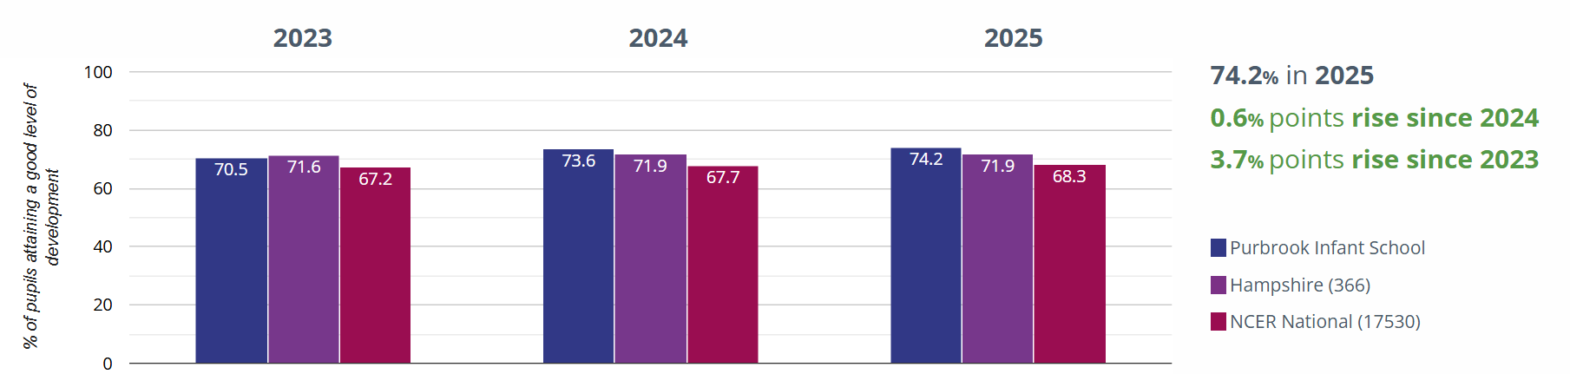
Average Point Score
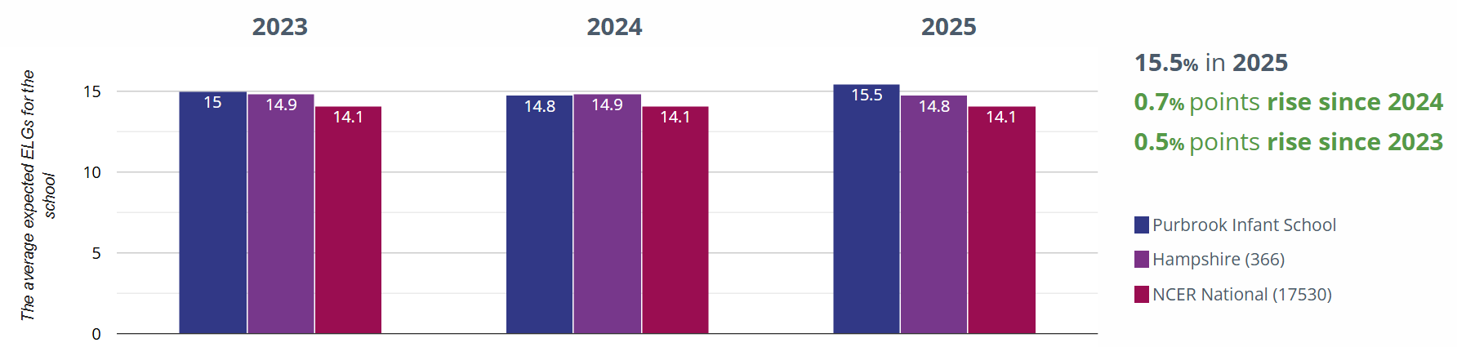
Year 1
Phonics
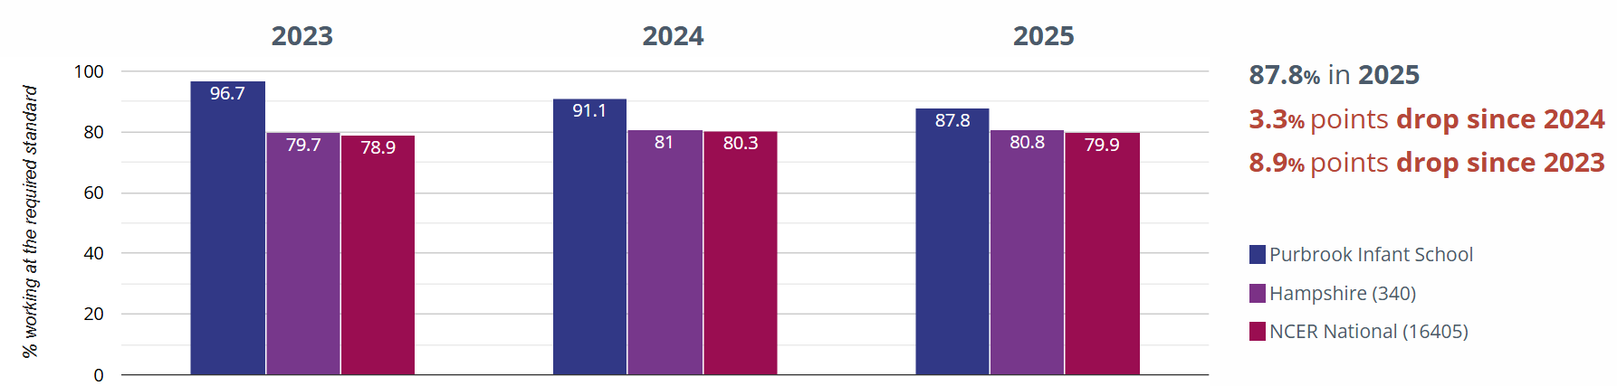

Year 2
Phonics
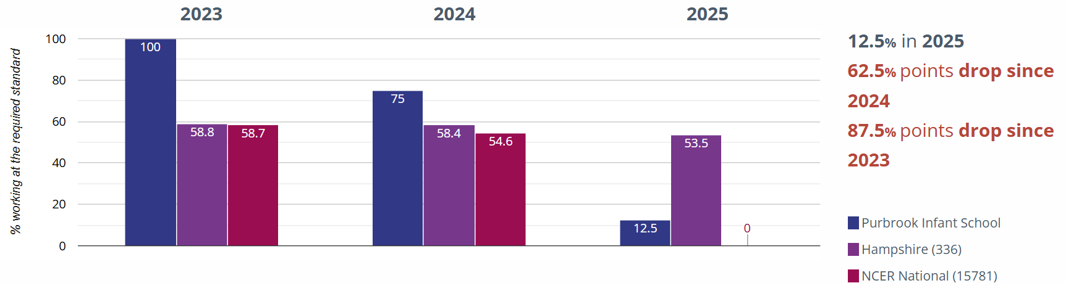

Year R break down
Prime areas | All | Boys | Girls | PP | Non PP | Disadv | Non  Disadv | SEND | Non  SEND
Listening, attention and understanding | 91% | 86% | 97% | 83% | 92% | 62% | 96% | 67% | 99%
Speaking | 94% | 92% | 97% | 83% | 96% | 77% | 97% | 76% | 100%
Self-Regulation | 96% | 94% | 97% | 92% | 96% | 92% | 96% | 81% | 100%
Managing self | 96% | 94% | 97% | 92% | 96% | 85% | 97% | 81% | 100%
Building relationships | 99% | 100% | 97% | 100% | 99% | 100% | 99% | 95% | 100%
Gross motor | 94% | 92% | 97% | 100% | 94% | 77% | 97% | 90% | 97%
Fine motor | 96% | 96% | 95% | 100% | 95% | 855 | 97% | 67% | 97%

Specific | All | Boys | Girls | PP | Non PP | Disadv | Non  Disadv | SEND | Non  SEND
Comprehension | 90% | 84% | 97% | 83% | 91% | 54% | 96% | 67% | 97%
Word reading | 85% | 80% | 92% | 83% | 86% | 46% | 92% | 57% | 94%
Writing | 80% | 75% | 87% | 83% | 79% | 38% | 87% | 52% | 88%
Number | 85% | 84% | 87% | 92% | 84% | 62% | 89% | 67% | 91%
Numerical Patterns | 84% | 82% | 87% | 92% | 83% | 62% | 88% | 67% | 90%

Wider Curriculum | All | Boys | Girls | PP | Non PP | Disadv | Non  Disadv | SEND | Non  SEND
Past and Present | 89% | 84% | 95% | 83% | 90% | 62% | 93% | 52% | 100%
People, Culture and Communities | 84% | 78% | 92% | 83% | 84% | 38% | 92% | 38% | 99%
The Natural World | 88% | 82% | 95% | 92% | 87% | 62% | 92% | 52% | 99%
Creating with Materials | 100% | 100% | 100% | 100% | 100% | 100% | 100% | 100% | 100%
Being Imaginative and Expressive | 97% | 96% | 97% | 100% | 96% | 85% | 99% | 90% | 99%

Year 1 breakdown of outcomes
ARE+ | All | Boys | Girls | PP | Non PP | Disadv | Non  Disadv | SEND | Non  SEND
Reading | 60% | 55% | 66% | 54% | 64% | 18% | 71% | 6% | 72%
Writing | 56% | 50% | 61% | 43% | 62% | 12% | 67% | 0% | 68%
Maths | 68% | 74% | 64% | 61% | 71% | 18% | 80% | 19% | 79%
Phonics | 88% | 81% | 94% | 79% | 92% | 59% | 94% | 50% | 94%

GDS | All | Boys | Girls | PP | Non PP | Disadv | Non  Disadv | SEND | Non  SEND
Reading | 22% | 19% | 26% | 18% | 25% | 0% | 28% | 0% | 27%
Writing | 3% | 0% | 6% | 0% | 5% | 0% | 4% | 0% | 4%
Maths | 3% | 5% | 2% | 4% | 3% | 0% | 4% | 0% | 4%

Year 2 breakdown of outcomes
ARE+ | All | Boys | Girls | PP | Non PP | Disadv | Non  Disadv | SEND | Non  SEND
Reading | 82% | 78% | 91% | 70% | 85% | 35% | 94% | 30% | 97%
Writing | 56% | 50% | 65% | 45% | 60% | 12% | 67% | 10% | 70%
Maths | 73% | 69% | 80% | 65% | 76% | 35% | 83% | 30% | 85%

GDS | All | Boys | Girls | PP | Non PP | Disadv | Non  Disadv | SEND | Non  SEND
Reading | 26% | 24% | 29% | 10% | 30% | 0% | 32% | 0% | 33%
Writing | 10% | 5% | 18% | 5% | 12% | 6% | 11% | 0% | 13%
Maths | 10% | 11% | 9% | 5% | 12% | 0% | 13% | 0% | 13%

Whole school break down
Gap between PP pupils and all pupils
 | ARE Gaps |  |  | GDS Gaps
 | Reading | Writing | Maths | Reading | Writing | Maths
Year R | 3%/8% | 4+% | 8+%/9+%
Year 1 | 7% | 19% | 10% | 7% | 5% | 1%
Year 2 | 15% | 15% | 11% | 20% | 7% | 7%

Gap between Boys and girls
 | ARE Gaps |  |  | GDS Gaps
 | Reading | Writing | Maths | Reading | Writing | Maths
Year R | 12%/13% | 12% | 3%/5%
Year 1 | 11% | 11% | 10+% | 7% | 6% | 3+%
Year 2 | 13% | 15% | 11% | 5% | 13% | 2+%

