

Special Educational Needs and Disability (SEND) Policy
2025 - 2026

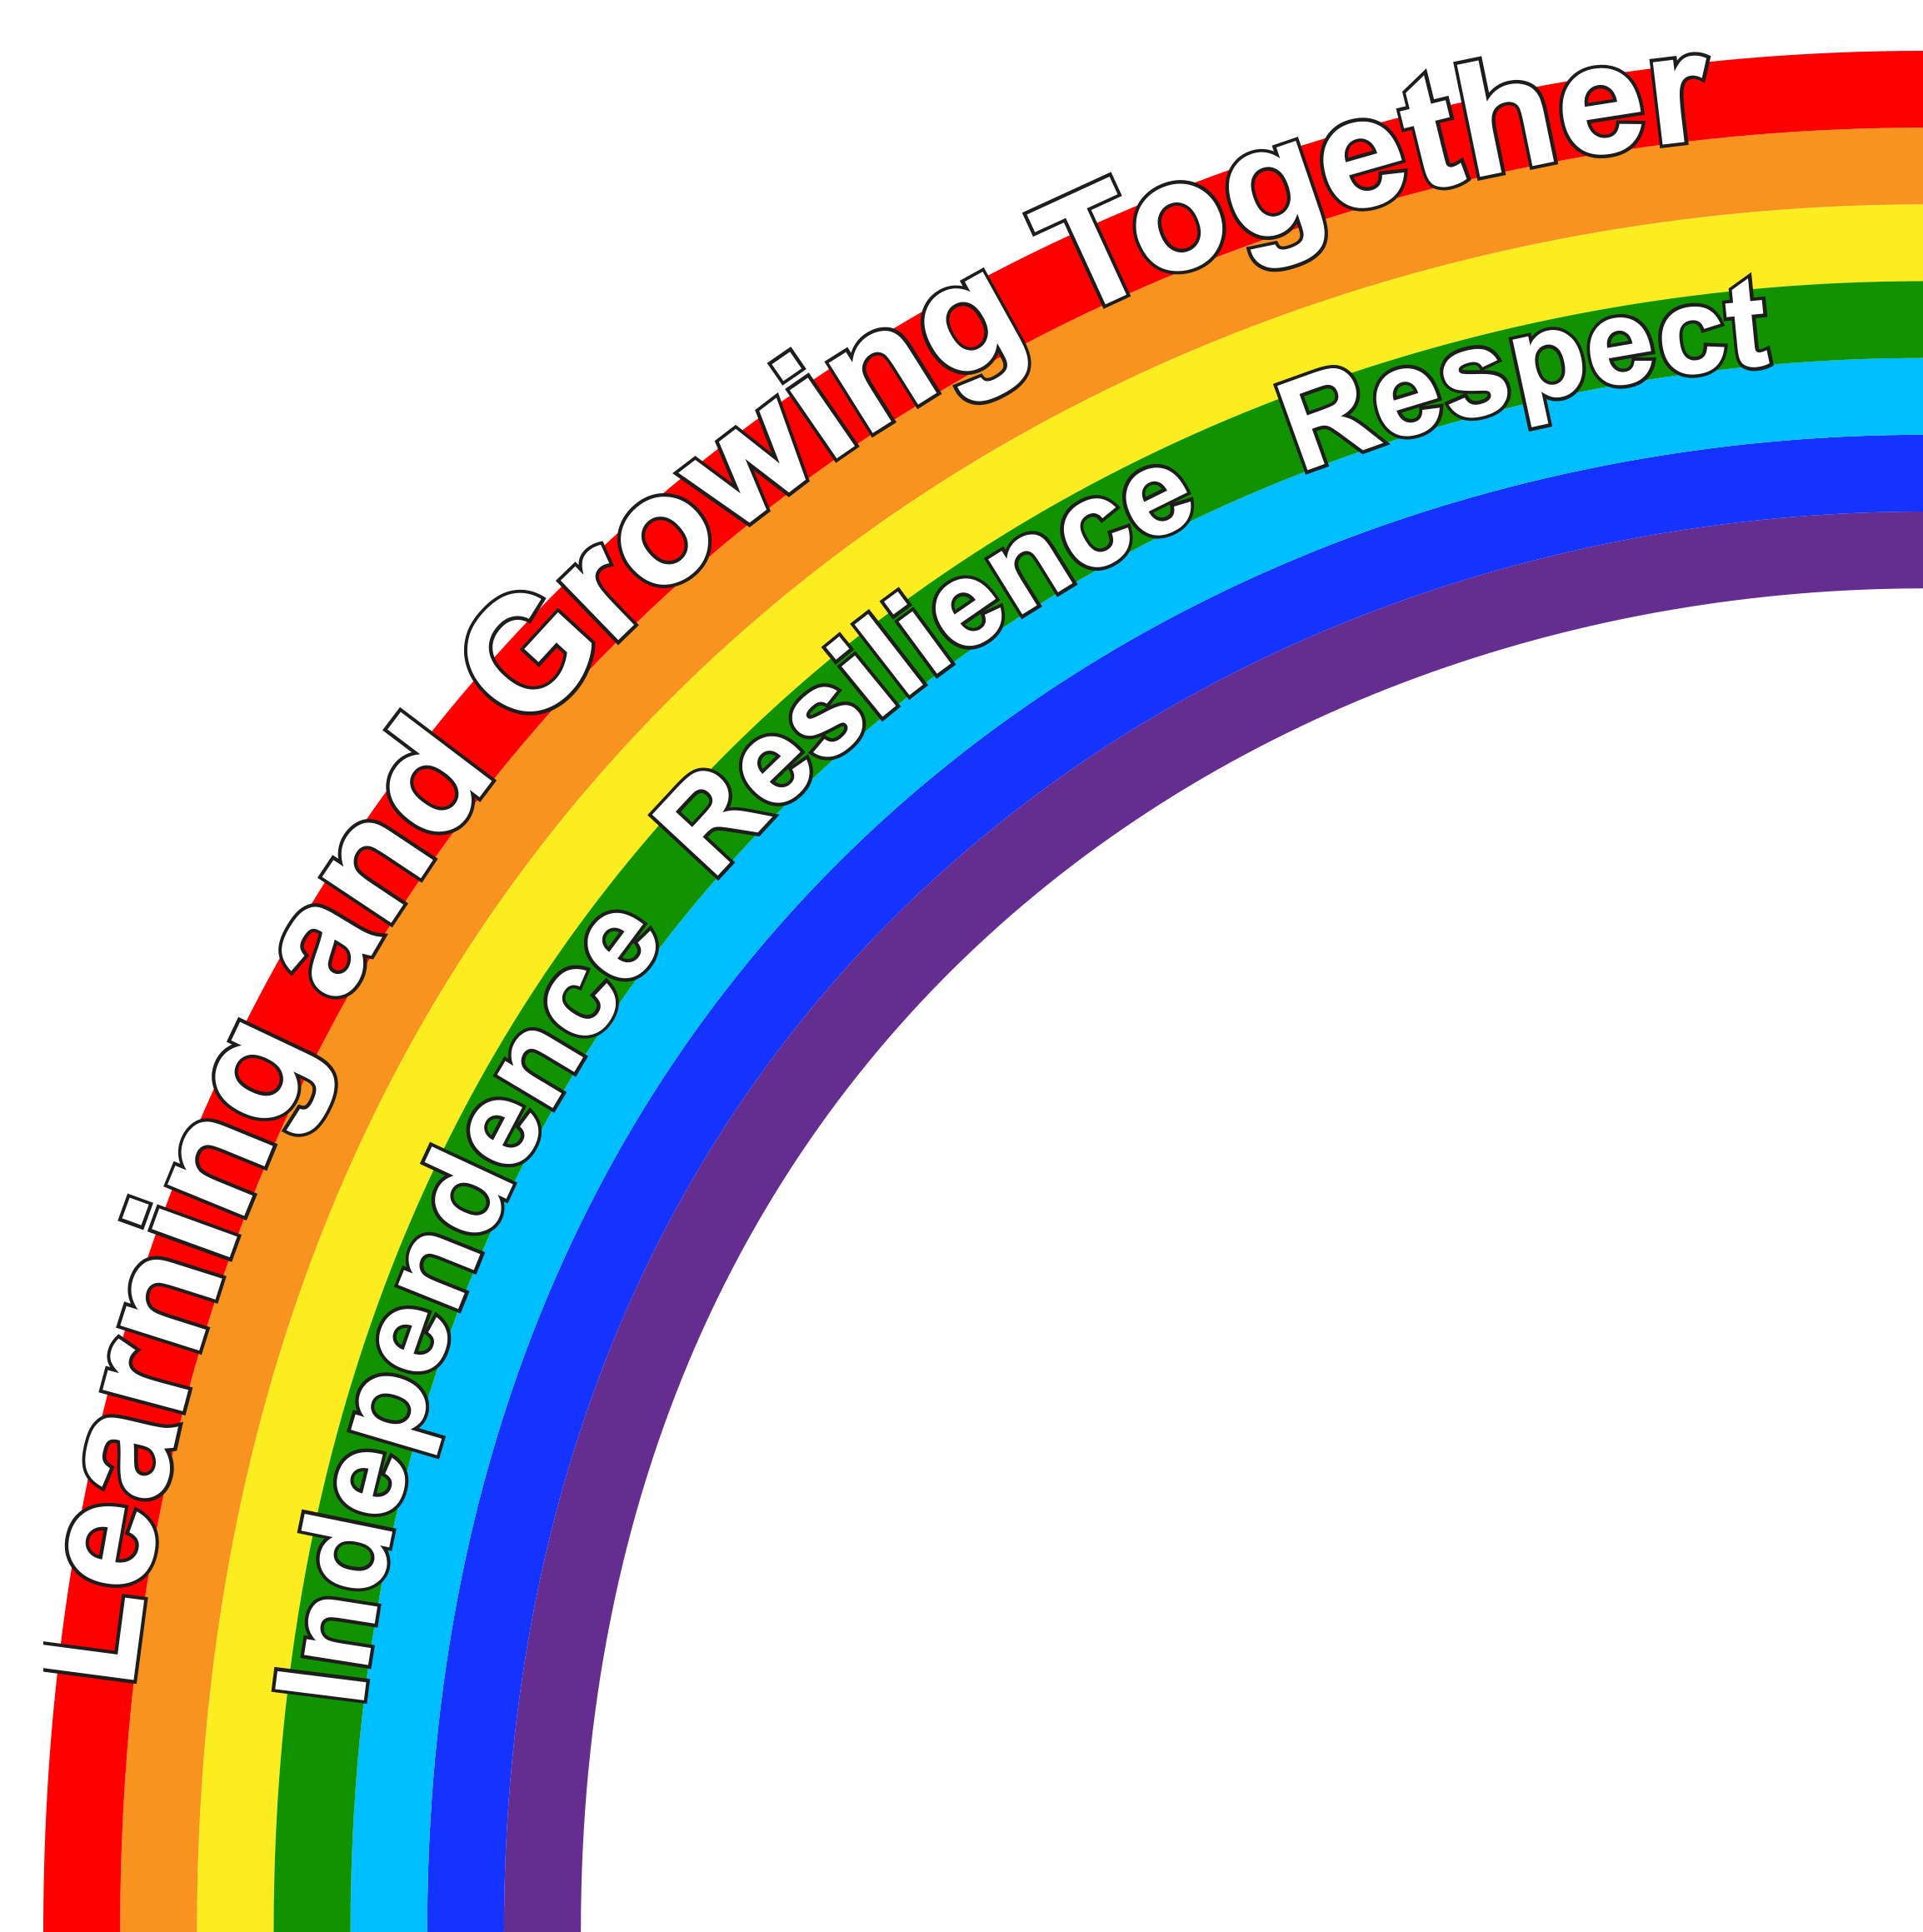

Our vision

Learning and Growing Together

*Resilience *Independence *Respect

At Purbrook Infant School, our vision is to nurture and grow our children into positive, self-regulated and ambitious learners who show resilience and confidence at each stage of their education.
All staff, children, parents/carers and governors aim to value and respect each and every one, regardless of our individual differences. We are committed to developing the learning of all children and adults. Everyone in our school is encouraged to develop academically, spiritually, morally, socially, culturally and physically.

Rationale

At Purbrook Infant School, we pride ourselves on being an inclusive mainstream setting who holds equality at the forefront.
We work within the Special Educational Needs and Disability Code of Practice: 0–25 years, which states that all children are entitled to an education that:
- is appropriate to their needs
- promotes high standards and the fulfilment of potential
- supports them to achieve their best
- helps them become confident individuals living fulfilling lives
- enables successful transition into adulthood
Our policy also recognises the importance of reducing cognitive and sensory overload for many children with SEND. We strive to embed good practice naturally throughout the school day so that children experience consistent, accessible learning environments where they can thrive. This includes careful attention to classroom organisation, predictable routines, task design and regulation opportunities.
We also recognise that executive functioning skills, including working memory, planning, organisation, inhibition and cognitive flexibility are essential to children’s learning. Where these skills are delayed or less developed, we adapt expectations, reduce cognitive load, model supportive strategies and ensure learning tasks can be accessed more successfully.

Contact details

At Purbrook Infant School, the Special Educational Needs and Disabilities Coordinator (SENDCo) is in charge of managing the provision and monitoring of children with special educational needs and disabilities (SEND) across both the Foundation Stage and Key Stage One. The SENDCo is Mrs Zoe Bailey who can be contacted via email or telephone:

z.bailey@purbrook-inf.hants.sch.uk / 023 92610 761

Statement

Our SEND policy has been developed using the school’s SEND Information Report (‘Local Offer’), which can be located on the school website, and reflects the SEND Code of Practice 0-25 years. In formulating and developing this policy, the SENDCo sought opinions and advice from parents of children with a special educational need and/or disability, and from the school’s SEND Governor.

All teachers of children with a special educational need or disability have responsibility for ensuring each child achieves their potential through careful differentiation, assessment, monitoring and target setting across a broad, balanced and innovative curriculum.

Admission arrangements

Once allocated a place at our school, the admissions arrangement for children with SEND do not differ from any other child. Additional consideration may be made however, where individual circumstances may impact transition. This may be in the form of extra visits to the school and school staff visiting the child in their pre-school setting to further build a trusting relationship. School and pre-school may suggest an additional meeting to include all parties involved in the child’s life, to ensure consistency between the settings within a transition partnership agreement (TPA). The SENDCo will liaise closely with parents, any outside agencies involved and feeder schools or pre-schools to ascertain details of children with SEND so that their needs can be readily met.

Aims

- To offer a multisensory curriculum to promote an equal opportunity for all learners to access a broad, balanced and relevant curriculum, making it accessible by tailoring planning, pitch, structure and provision
- To provide an environment that is conducive and inclusive to the individual needs of all pupils in order that where possible, they integrate into the classroom with their peers. When making environmental changes, considering sensory and cognitive load, predictability, regulation needs, seating, visual supports and adaptations for specific needs such as dyslexia.
- To ensure that the needs of children with SEND as well as their barriers to learning, are identified early on, and that the appropriate provision is put in place to support
- To embed practices that support regulation throughout the day, rather than relying solely on additional intervention sessions.
- To consider the whole child; ensuring all basic needs are being catered for as a priority, in order that the child is ready to learn
- To raise expectations and aspirations for all pupils and encourage and openly value their contributions to school life regardless of individual differences
- To develop a strong, positive and supportive partnership between home and school, in order that our SEND pupils have equal opportunities to be included, where appropriate, in discussions regarding their provision and education
- To set targets and closely monitor teaching and learning to ensure children make good or better progress academically, socially and emotionally
- To enable all children, where suitable, to have access and involvement in wider curriculum opportunities including prefects, school council and school clubs
- To take account of pupils’ views and opinions, as well as those of their family, when setting and reviewing individual targets and programmes of support, including Individual Education Plans (IEPs/Puffin Passports), Educational Health Care Plans (EHCPs) and Transition Partnership Agreements (TPAs). To consider the views of all children, including those with SEND, when carrying out pupil conferences
- To nurture the development of children’s self-confidence and support the development of their knowledge of how they learn best, tailoring practice accordingly. This will include careful consideration for task design when allowing for differences in mental capacity and executive functioning skills.
- To nurture children’s emotional literacy to enable them to understand and manage their emotions
- To fulfil Local Authority requirements including completing the documentation required when requesting an Educational Health Care Plan (EHCP), reviewing it or considering deceleration or a change of placement.

Identifying special educational needs and disabilities

The school promotes the early identification of individual needs in order to ensure that children can access all areas of the curriculum to their best ability, and make the best possible progress.

We recognise that a child has a special educational need and/or disability if he/she has a learning difficulty or disability which is significantly greater than the majority of children of the same age, despite carefully tailored planning and additional provision to support them.

Special educational needs and provision can be considered as falling under the following broad areas:
- Communication and Interaction
- Cognition and Learning
- Social, Emotional and Mental Health
- Sensory and/or Physical

The purpose of identifying the area of need is to decide on the most appropriate support for the child.
We also consider whether a child’s presentation may be linked to:
- sensory processing differences
- high levels of cognitive load
- reduced working memory
- challenges with executive functioning
- anxiety linked to unpredictability or overwhelming environments
We aim to understand the root cause of a child’s barrier to learning so that provision is appropriate, all-inclusive and sustainable throughout the day.
Provision may take the form of subject specific intervention, changes to lesson structure to include pre-teaching and consolidation, additional scaffolding or resourcing and adaptations to the environment, pace and ratios where possible. Where specific expertise are required, support may be sought from outside agencies.

All provision is carefully monitored and altered accordingly where needed, to ensure it has the desired impact.

Individual needs or circumstances which are not necessarily considered as SEND but may impact on progress and attainment are as follows;

- Disability (the Code of Practice outlines the “reasonable adjustment” duty for all settings and schools provided under current Disability Equality legislation – these requirements for adjustment alone do not constitute SEND). Changes must be made to an assessment or to the way an assessment is conducted to reduce or remove a disadvantage caused by a child’s disability. They are needed because some disabilities can make it harder for children to show what they know and can do in an assessment than it would have been had the child not been disabled
- Attendance and punctuality
- Health and welfare
- EAL (English as an Additional Language)
- Being in receipt of Pupil Premium Funding or meeting criteria for being considered a school disadvantaged child (including a child who has experienced Adverse Childhood Experiences (ACEs))
- Being a Looked After Child (LAC), child under a Special Guardianship Order (SGO) or having been in care – Post LAC (PLAC), as well as having experienced any significant input from Children’s Services, the police or health care
- Being a child of serviceman/woman

The process by which our school manages children with SEND

Our school has a graduated approach to the management of children with SEND. Each teacher has a record of the children in their class currently identified as having SEND. These records may include a plan detailing personalised targets tailored to the child’s needs and the provision in place that will support them. This document we have called a Puffin Passport.

Before a child is placed on the school’s SEND register, the following processes will be undertaken. These have been taken directly from the SEN code of Practice 0-25 years:

Assess
5.39 In identifying a child as needing SEND support, the class teacher, working with the setting SENDCo and the child’s parents, will have carried out an analysis of the child’s needs. This initial assessment should be reviewed regularly to ensure that support is matched to need. Where there is little or no improvement in the child’s progress, more specialist assessment may be called for from specialist teachers or from health, social services or other agencies beyond the setting. Where professionals are not already working with the setting, the SENDCO should contact them, with the parents’ agreement.

Plan
5.40 Where it is decided to provide SEND support, and having formally notified the parents, (see 5.38 above), the class teacher and the SENDCO should agree, in consultation with the parent, the outcomes they are seeking, the interventions and support to be put in place, the expected impact on progress, development or behaviour, and a clear date for review. Plans should take into account the views of the child. The support and intervention provided should be selected to meet the outcomes identified for the child, based on reliable evidence of effectiveness, and provided by practitioners with relevant skills and knowledge. Any related staff development needs should be identified and addressed. 5.41 Parents should be involved in planning support and, where appropriate, in reinforcing the provision or contributing to progress at home.

Do
5.42 The class teacher, usually the child’s key person, remains responsible for working with the child on a daily basis. With support from the SENDCo, they should oversee the implementation of the interventions or programmes agreed as part of SEN support. The SENDCo should support the class teacher in assessing the child’s response to the action taken, in problem solving and advising on the effective implementation of support.

Review

5.43 The effectiveness of the support and its impact on the child’s progress should be reviewed in line with the agreed date. The impact and quality of the support should be evaluated by the practitioner and the SENDCo working with the child’s parents and taking into account the child’s views. They should agree any changes to the outcomes and support for the child in light of the child’s progress and development. Parents should have clear information about the impact of the support provided and be involved in planning next steps.

Although assessment is no longer statutory, the school continues to refer to its own assessment tools in order to track progress, monitor and plan effectively.
The school’s SEND toolkits are a breakdown of learning objectives (taken from a multitude of assessment documents), simplifying them into more manageable steps. This is to enable those children who are less likely to progress and attain at the rate of their peers, to demonstrate the smaller steps they have progressed through. This toolkit is used to inform individual targets found on the child’s Puffin Passport.
Where children are unable to access the pitch of the toolkits, the Early Years’ Developmental Checklist is used in place.
An EHCP and/or relevant reports from outside agencies (such as Speech and Language Therapy or Educational Psychology) detail the child’s next steps in learning, and the provision they require to support them in progressing. These contribute towards the child’s individual targets.

Puffin Passports are working documents setting short term targets that are specific to an individual. They are monitored and updated on a regular basis and are reviewed frequently by the SENDCo. These documents also have a record of the provision in place for the SEND child, detailing what the area of needs is, the provision in place, how regularly this is being offered and the impact this is having. Evidence of progress may be collated in the form of teacher/TA notes, photos, voice notes, or examples of the child’s learning. The school’s online learning platform can also be utilised to present this progress.

All special needs information is circulated between home, school staff and outside agencies, and is passed on to the next class teacher or receiving school upon transition.

Responsibilities

Special Educational Needs Coordinator:

The Special Educational Needs and Disabilities Co-ordinator is responsible for: -
- The day to day implementation and delivery of the SEND policy, in conjunction with the head teacher
- Liaising with and advising all staff members, teaching and non-teaching, on matters relating to SEND
- Co-ordinating and monitoring the provision for children with special needs or disabilities, including the suitability of the environment
- Monitoring and tracking the academic and emotional progress of children on the special needs register
- Providing SEND and continued professional development (CPD) training for staff
- Liaising with the nominated SEND Governor of the school
- Liaising with and making referrals to outside agencies, including health and outreach services
- Co-ordinating SEND reviews and organising annual reviews for children with EHCPs
- Producing written reports following reviews and annual reviews
- Advising Teaching Assistants (TAs) and teachers on the writing of and use of Puffin Passports
- Maintaining links with parents of children with SEND through the organisation of meetings
- Securely storing confidential and personal information related to SEND
- Monitoring SEND provision throughout the school through observations, book, planning and Puffin Passport scrutiny, discussions and data analysis
- Liaising with teaching and support staff to identify resource and training implications
- Reporting to the Governing Body on the progress of children with SEND
- Ensuring the SEND policy is presented to and reviewed by staff and governors

Teaching and support staff

- It the responsibility of all teaching staff, on a day to day basis, to deliver quality first teaching to all children, including those with SEND, and to ensure that lessons are challenging in order for children to make the best possible progress and reach their fullest potential
- Teaching staff are responsible and accountable for the progress and attainment of the pupils in their class, including those pupils who access support from TAs, SNAs or other support staff. This will mean regularly liaison with the person(s) delivering the specialist interventions and adapting practice where the desired impact is not being achieved
- It the responsibility of all teaching staff, overseen by the SENDCo to ensure that the environment, provision and planning support an inclusive classroom where children, regardless of needs, can access learning, integrate into the classroom and contribute their ideas
- Each term the school’s leadership team monitor the quality of teaching and learning for all pupils, including those at risk of underachievement. Where necessary, professional development is provided to improve teachers’ understanding of effective strategies to support vulnerable pupils including those with SEND
- In deciding whether special educational provision is needed, the class teacher and SENDCo will liaise closely with the family and child (where appropriate), as well as external professionals to consider the individual’s ability to access to school life, the barriers that may be impeding, their progress and ability to regulate their emotions
- Where there is a high level of need, the school will arrange for assessments to be carried out with the permission of the child’s parents. These might be conducted by experts from outside agencies such as Speech and Language Therapy or Educational Psychology.

Following the application for an Educational Health Care Plan

Where a child’s needs are considered as significantly more complex than that of their peers, the school may in some cases, apply for additional support through the implementation of an Educational Health Care Plan. If successful in ascertaining, having an EHCP helps enable the school to make the necessary adaptations that go above and beyond those required to meet the needs in the bottom 5% of the children in their class.

Where an EHCP is applied for, the following process is followed:

The Local Authority (LA) will consider all the evidence and may ask for further information and the views of the child and adults involved, including school, family and external professionals. They will then make a decision as to whether or not to carry out further assessments and if successful, issue an Educational Health Care Plan. The LA then makes suggestions around practice and provision based on their knowledge of the child and their needs. They monitor and review this process and an annual review will take place with all parties involved to make changes if necessary.

Accurate records of progress, targets set and agencies involved are maintained and accessible to all who work with an individual child. There is also provision for regular reviews of progress and updating of targets with all those involved with the child.

SEND Governor

The SEND governor will:
• Help to raise awareness of SEND issues at governing body meetings
• Monitor the quality and effectiveness of SEND provision within the school and update the governing body regarding this
• Work with the Head Teacher and SENDCo to determine the strategic development of the SEND policy and provision in the school
• Consult the Local Authority and the governing bodies of other schools, when it seems to be necessary or desirable in the interests of coordinated special educational provision in the area as a whole
• Ensure parents/carers are notified of a decision by the school that their child has special educational needs and/or a disability
• Report on how the school’s SEND policy is being implemented and how resources are allocated
• Ensure that the SEND Code of Practice is followed.

Designated Safeguarding Lead

The school has five members of staff trained to deal with safeguarding concerns. These are the Head Teacher, two Assistant Head Teachers, both trained ELSAs and the school’s Parent Liaison Officer. Staff can be contacted via the school office or email.

Specialism and special facilities - allocation of resources

- The school employs a minimum of one TA for each class. Special Needs Assistants (SNAs) work with those children who are issued an EHCP or are significantly more complex in need, than the bottom 5% of their class. SNAs and other support staff work across the school to further support children with SEND, where the need is greatest.
- The school has two ELSAs who supports where there is an emotional need regardless of whether this impacts on learning. It is important to recognise that lacking social skills can present a barrier to a child’s ability to access school life. They may have poor self-esteem and low confidence which may make them reluctant to attempt new learning.
- Where external factors are impacting on the child’s learning and/or wellbeing, our Parent Liaison Officer maybe be signposted to support the family. This may be in aiding parents to ensure their child’s attendance or punctuality is improved, advising them on the various charities and organisations that could support with food/clothing/housing/finances etc and in general, being a point of contact to support where the need is greatest.
- Outreach support is available from local special schools. This is to equip the school’s staff in setting up systems for children who have specific learning difficulties.
- The school accesses support from the local Primary Behaviour Support Team who provide advice and guidance on how best to support children with social, emotional, mental health difficulties which may present as behavioural difficulties. Families also have access to a wellbeing service via the same body, to support challenging behaviours in the home
- The school also liaises with the Virtual School regarding children in care, the Local Authority for support in moving children into specialist placements and EMTAS to support children and families for whom English is an additional language
- The school has a trained Higher Level Teaching Assistant who is able to deliver a variety of interventions that are set up to help children make accelerated progress. These interventions include language and or social skills development programmes such as Early Talk Boost/Talk Boost, ICW (Information Carrying Words) programme and Bucket Time which is a programme to support attention and focus.
- The school has a qualified Speech and Language Therapy Assistant, who works with children for whom SaLT is a primary area of need. She does so on a 1:1 or small group basis, through her work with the school’s designated Makaton Marvels, and through the delivery of interventions such as Narrative Skills and Language for Thinking.
- Support and teaching staff also deliver other subject specific programmes of support including Number Sense.
- Further interventions include sensory circuits, programmes to develop core strength, coordination and stamina (The NHS Achieving Body Control programme (ABC)) and in more extreme cases, adaptations to whole class ratios to support more complex SEND needs.
- There are other interventions that run across the school to support speech and language, maths, literacy, phonics development and social and emotional skills.

At the present time, the Year R facilities are suitable for wheelchair access and there is a child’s disabled toilet. The medical room is accessible from the Year R facilities. There is one further toilet suitable for wheel chair users or those with limited mobility. The school has been adapted to ensure that, where steps are located, hand rails are accessible to support mobility. Footsteps and toilet frames have been purchased to support children in sitting and in accessing the toilets/sinks. Adaptive cutlery, scissors, rulers, glue, musical instruments and key pads have also been purchased to enable all children to physically access school life. The Specialist Teacher Advisor Service offer outreach support, training, resourcing and guidance for children with specific needs such as a visual or hearing impairment. This service can be accessed to train staff in the use of Braille for example, and other supporting provision.

Staff development

We recognise that teaching and non-teaching staff will require regular in-service training on aspects of special needs and inclusion in order to update and inform their practice and to share policy changes.
Staff training needs are audited regularly; and some of these will be specifically linked to SEND.
Staff working with children with special educational needs and disabilities attend meetings, training and professional development INSET days. Appraisals for TAs and SNAs are carried out by the Assistant Head Teacher for Inclusion and Assistant Head Teacher for Curriculum.
Partnership with parents

The school works closely with parents/carers. Parents/carers are involved at every stage of the special educational needs and disabilities process and we value the information and insight they can provide us with.

Parents/carers will have been consulted and concerns will have been expressed by the school’s teaching staff or SENDCo before a Puffin Passport or referral is made. Puffin Passports often include actions that parents/carers can carry out at home with their child. Parents are kept fully informed about the progress their child has made at review meetings.

We encourage parents/carers to contact us with details of any medical condition which may affect their child’s education, and to plan with us to meet any particular needs that their child may have as a result of a medical condition. In certain circumstances, an Individual Health Plan or IHP will be developed.
We will inform parents/carers at all times of any intention we have of making referrals to outside agencies.

The voice of the child

At Purbrook Infant School we are committed to developing ways of engaging children in their learning and in decision making. Work on citizenship and opportunities to take on key responsibilities has increased levels of pupil participation. The SENDCo will carry out pupil conferencing to ascertain their preferred means of learning, topics of interest or dislike and improvements that might affect their engagement in school life.

Links with other schools and transfer arrangements

Close liaison with pre-schools forms an important part of ensuring continuity and progression for children identified in the Early Years’ settings as having special educational needs and/or disabilities. This liaison will involve visits to pre-schools and meetings with parents/carers, key workers and if required, outside agencies, to ensure a smooth transition into school for the child.

Close liaisons take place with the SENDCo at Purbrook Junior School (or chosen setting) prior to children transferring at the end of Key Stage 1. Any annual reviews taking place will include invitations to the staff and SENDCo of the receiving junior school.

If a child with an EHCP is transferring to a specialist placement, we will make arrangements with that setting to ensure the best possible transition. If we are to receive a child with an EHCP from another school, we would visit the setting and recommend a visit/s for the child to our setting, as part of their transition to our school. Transitions, where necessary may take the form of a more gradual approach.

Purbrook Infant School is a member of the SENDCo Circle as well as ELSA/TALA supervision. Regular cluster meetings are held, usually chaired by an Educational Psychologist in order for professionals to share good practice and keep abreast of updated legislation and expectations.

Links with other agencies, organisations and support services

The school works closely to support children and parents using a range of external agencies and support groups.

These include:-
- Havant School Nursing Team
- Speech and Language Therapy
- Educational Psychology
- Occupational Therapy
- Physiotherapy
- Behaviour Support Team including the wellbeing team
- Mental Health Support Team
- Specialist Teacher Advisory Team
- ELSA Support Group
- Riverside Outreach
- Waterloo Outreach
- CAMHS, The Owl Centre, Portsmouth ND Team
- Southern Domestic Abuse
- Hampshire Youth Access
- Portage
- The SEND / Inclusion Team
- SENDCo circles
- EMTAS

Evaluating success

The Special Educational Needs Policy will be reviewed annually or where there are changing circumstances.

The SENDCo will monitor effective communication between staff, parents and outside agencies through SEND review meetings including evaluating provision and the setting of new targets. Reviews of provision take place at least half termly and more often if the need arises. Children with an EHCP will have an annual review with all the professionals involved in the child’s learning.

The class teacher, TA, SNA, HLTA and SENDCo will monitor the progress made against personal targets on a regular basis. Regular meetings will be held to evaluate and re-set targets for any child not achieving current targets.

The SENDCo, SaLTA, HLTA, TAs or SNAs running intervention programmes will meet at least termly to discuss the progress of individuals and re-set targets as necessary.

Exiting the SEND register

When it is felt that a child no longer requires additional support to make good progress in their learning and to reach age related expectations, they may be removed from the SEND register. However, the child’s progress will continue to be closely monitored to ensure that they do not regress. At this point the child will be considered Ever SEND.

Complaints procedures

We aim to maintain a close working partnership with parents and carers and, if parents are concerned about any aspect of their child’s education, they are encouraged to approach their child’s class teacher in the first instance.

Informal complaints or concerns can be discussed with the class teacher or SENDCo by appointment.

Formal complaints can be discussed with the head teacher in order to ensure a satisfactory resolution. If matters cannot be resolved the parents/carers would be advised to write to the chair of the Governing Body outlining their concerns. Please refer to the school’s Local Offer for further information.

Linked policies

Bullying policy
Equalities policy
Accessibility policy
Admissions policy
Safeguarding policy
Complaints policy
Assessment policy
Policy for Teaching and Learning
Behaviour policy

Reviewed November 2025

